HS Sculpture Wire/Movement Unit
Name:

ELIZABETH BERRIEN’S CREATIVE PROCESS
Assignment: Read this and notice the process she goes through. Try to think of artmaking not as just the act of making something but also including the preperation, warm up, environment etc. I am looking for margin notes, underlines. Anything that stands out to you and why. Make sure to keep your notes clear since I will be reading them.

5

By: Elizabeth Berrien

To begin a wire sculpture, I gather all the reference images I can and plaster the walls and floor of my studio with them. Then I start my "pre-wiring dither" selecting the right wire, fixing a cup of coffee or tea, putting on slippers, putting on some music, as I settle into a meditative mood. Sometimes my husband reads to me as I wire - this week it's a biography of Queen Elizabeth I. Sometimes it's a murder mystery, or something from Terry Pratchett - anything to engage my surface mind while my subconscious runs loose with the wire.
If I'm working on a bear, I may immerse myself in the images around me til I forget whether I'm human or bear. I start at the animal's head, twisting a few single strands of wire together to create a sort of nucleus.
As I continue to weave in dozens or even hundreds of additional wires, I seek out and follow the energy lines of muscle, bone and fur that translate the bear's spirit and essence.
Often, I get a sense that the half-done sculpture is already alive, watching me as I work and suggesting that I veer this way or that with the wires. The feeling of communing with the animal is even stronger when I weave from the inside of a large work; it's like looking outward through the bear's eyes and feeling its heart beat.
For tall animals like life-size bears and giraffes, instead of climbing a ladder I use this system: kneeling on a floor cushion, I weave up the head and/or neck til it's too ungainly to continue as lapwork. Then I attach it to a rope suspended by an overhead pulley and hoist it. From then on I weave downward, while hoisting the animal ever higher.
Sometimes a half-done animal, emerging from its cloud of twisted wires, looks so magical just as it is that I stop working on it - and leave it as an expressive "figment".
As I create my "three-dimensional line drawings", I incorporate a hidden, embedded structure to the sculptures, making them much more rugged than the airiness of their lines would suggest.
The feedback I've had from people who own my sculptures has made me aware that they seem to put out more good energy than I'm aware of putting in. Now that I'm aware of the semi-metaphysical aspects, I try to just let the animal's personality come through without imposing my artistic ego into it. All my works have a basic infused intent - to bring blessings and harmony to the people that come in contact with them.

WIRE METHODS

9
Assignment: Following allong with Mr P’s make the following forms and get his initials next to the form you created for full credit

Chicken wire method  sphere | Wiregami method  flower | Continuous wire method  cactus
Teacher  initials | Teacher  initials | Teacher  initials

MOVEMENT STUDY

8
Assignment: In 1&2 describe how you see the principle of movement being implemented. In 3&4 find your own sculpture images and them below in the same way. Remember that principles are carried out throught the strategic use of the elements so you should be able to describe it in terms or how a particular element is used.

1. 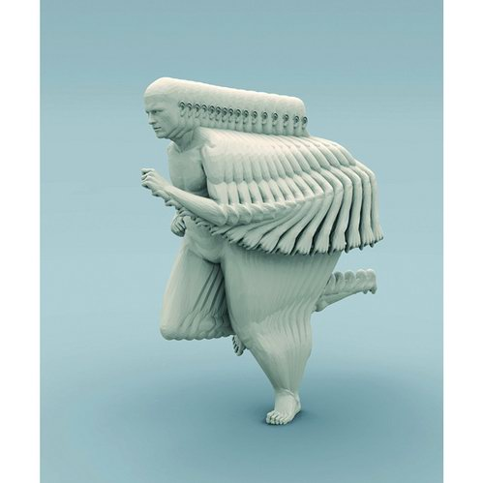 | 2. 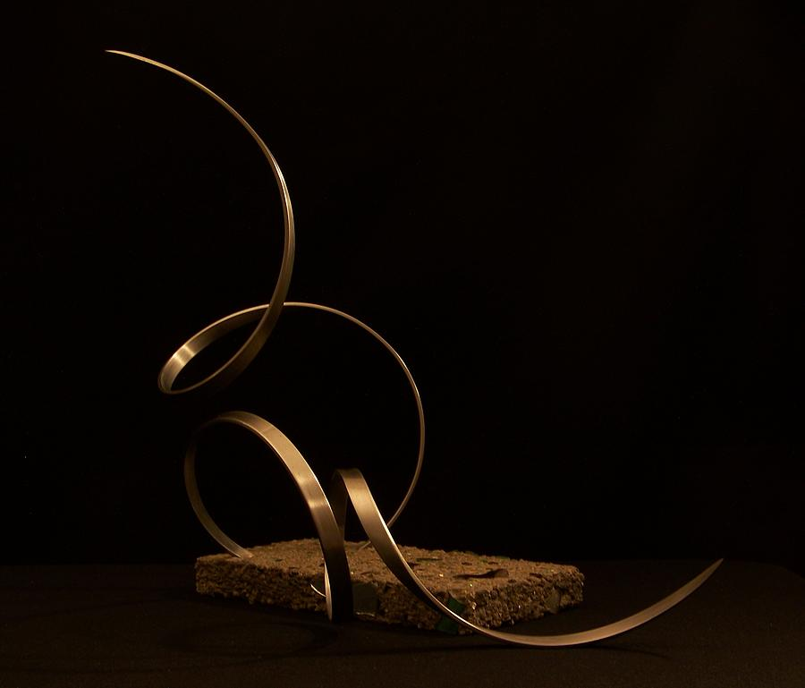
3. | 4.

1.

2.

3.

4.

REFFERENCE IMAGES

11
Assignment: Collect 4 different photographs of real leafless trees that are different varieties (maple, willow, bonsai, etc.) These pictures you should look at closely because you should loosely base the structure of your tree on these images

Tree type (1pt): | Tree type:
Pic 1(1pt) | Pic 2
Tree type: | Tree type:
Pick 3 | Pick 4

List 3 tree attributes you observe in these pictures that will help you make your tree.

THUMBNAILS

8
Assignment: Create at least 4 drawings in the space provided below to brainstorm what you might want your sculpture to look like. Circle the one you want to try and go with and remember that your sculpture must capture movement in some way.

WIRE TREE/MOVEMENT SCULPTURE
Objective: Learn to use wire as a sculpture medium showing comprehension and use of the elements and principles of art and design.

Project – Create a Tree sculpture using wire that shows the principle of movement
- Start by twisting a few wires around each other to form the trunk
- Make sure to keep long tales for the branches and medium tales for the roots
- Continue adding wire until finished.
- GOOD LUCK!

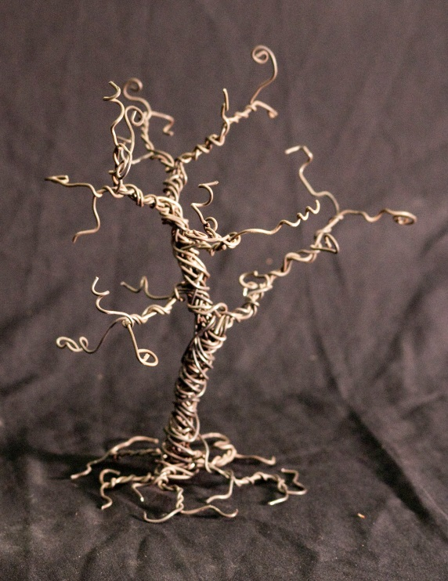

40
Teacher | Student | Description
/10 | /10 | Fulfills requirements and finished
/10 | /10 | Craftsmanship: carefully and deliberately built. Stands freely and is stable without support.
/10 | /10 | Composition: Successfully incorporated the principle of movement
/10 | /10 | Studio Work Ethic – on task, problem solving, positive attitude

CRITIQUE

6
Assignment– In complete sentences evaluate the project by answering the following questions and be descriptive.

- Are you happy with your work? Explain. (3pts)

- Do you feel like you successfully showed an understanding of movement in your piece? explain (3pts)

