Art 9 Value Unit
Name:

PHIL HANSEN NOTES 9th
Objective: To introduce students to Phil Hansen’s story of creativity. To create a wide range of values using an unconventional method. To learn the value of using a grid in drawing.

10
Assignment: Watch the following videos and write a short thoughtful response

- Watch Phil Hansen’s A Moment video on YouTube
- Watch Phil Hansen’s Painting with Puppies on YouTube
- You saw Phil create 3 projects. The portrait, the stamp puppy and the running dogs. What stands out to you about his artwork and why. Is it the creativity, the words, the process? Tell me what you think.

- Watch Phil’s Ted talk: Embrace the shake.
- In Phil’s case his limitations forced a measure of creativity that he would not likely have discovered otherwise. Do you think this is true for most people or do people give up? Have you ever been faced with a limitation that has caused you to give up or have you found a way to harness it and make it work for you?

GRID PRACTICE 9th
Assignment: Use the grid below to help you blow up the small drawing of Elmo’s face. Treat each box like its own individual drawing and gauge the distances, measure with your pencil. Do anything you can to get the lines placed in the right spot and shaped correctly.

5
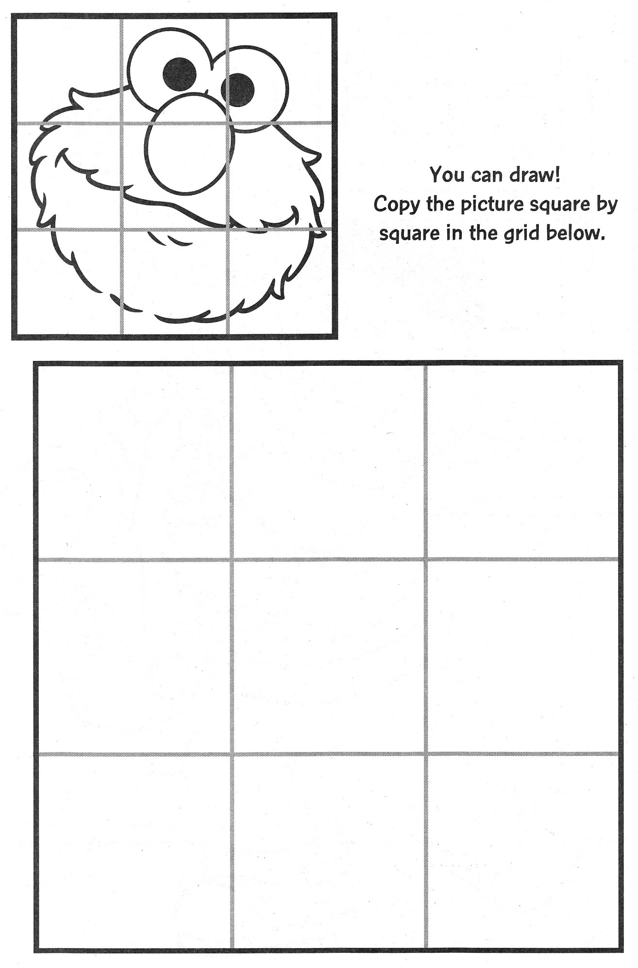

Darkest Value | 10
Medium Value
Lightest Value
THUMB PRINT VALUE BAND EXERCISE 9th
Assignment: Using a stamp pad and your thumb create a value band of 5 distinctly different values. Build them up slowly.

PHIL HANSEN’S THUMB PRINT 9th
Project – Create a large portrait as a class using a grid, thumb prints, and stamp pads

- Fold an 8 ½ x 11 sheet of copy paper diagonally and cut the extra off to make a square that is 8 ½ x 8 ½
- Fold your 2 inch piece of paper into a 4 x 4 grid
- Fold your 8 ½ x 8 ½ paper into a 4 x 4 grid
- Start stamping away

NOTE: No white space should be left without value. Make sure you unload the darkest stamps on a scrap so that you can put down a light layer of value in the lightest areas.

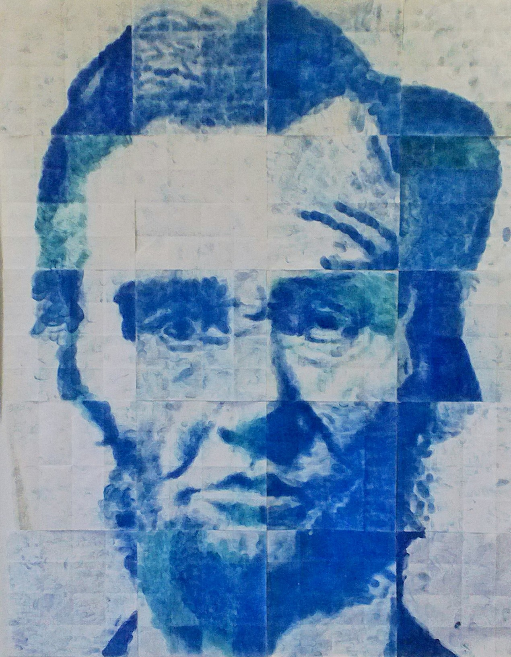

40
Teacher | Student | Description
/10 | /10 | Fulfills requirements and finished
/10 | /10 | Value: values rendered are as they appear on 2 inch reference
/10 | /10 | Accuracy: Values positioned correctly based on 2 inch reference
/10 | /10 | Studio Work Ethic – on task, problem solving, positive attitude

6
CRITIQUE
Assignment– In complete sentences evaluate the project by answering the following questions and be descriptive.

- Explain in your own words how a grid can help in creating artwork. (2pts)

- Explain how size can help when using a grid to put things in the right spot (2pts)

- Write a quick response to this project. liked, disliked, why.(2pts)

