Pen & Wash: Perspective Unit
Name:

PERSPECTIVE NOTES

7.5
Assignment: Following allong with your teacher fill in the notes below

Draw a line to connect the definition to the term.

1. Horizon Line (HL)–

2. Front Face/Edge (FF/FE)–

3. Vanishing point (VP)–

4. Orthogonal lines (OL)–

- The surface or edge closest to the viewer on an object.

- This is the spot where all the lines lead to as they appear to go further away.

- This shows where the sky and ground meet. Also shows how high above the scene or below the scene the viewer is.

- These are the actual lines traveling to the vanishing points from the front face.

5. Locate the VPs by marking in at least 3 OL for each VP. Use a ruler to draw them. Where they intersect is the vanishing point. (3pts)

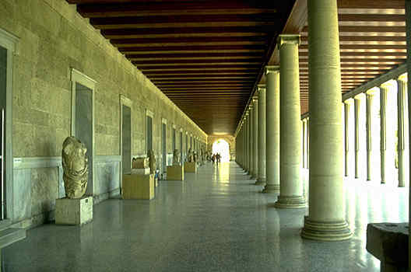

6. Locate the 2 VP by marking in 4 OL (2 for each VP) using a ruler to draw them in. Where they intersect is the vanishing point. (4pts)

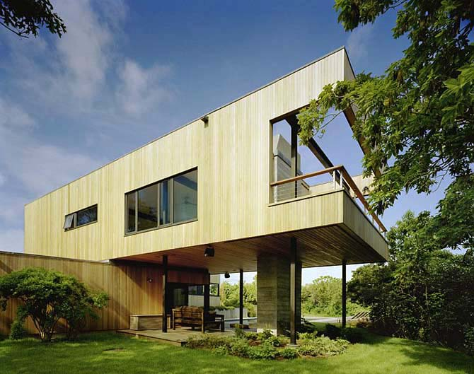

7. Locate the 3 VP by marking in 6 OL (2 for each VP) using a ruler to draw them in. Where they intersect is the vanishing point. (4pts)

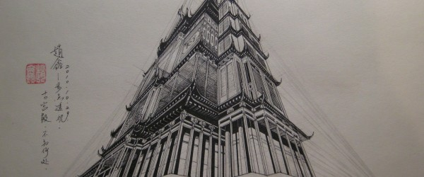

RULES OF 2PT PERSPECTIVE 8th
STEPS

1. Draw FE – edge should be parallel to the sides of your paper.

2. Draw OL – from top and bottom of FE to each VP. This will be 4 lines.

3. Draw BE – edges should be parallel with corresponding FE.

4. Draw last 2 OL from corners of form closest to the HL. Line them up with VP1 & VP2. Where they intersect is the back corner of box.

5. Erase all extraneous lines. Also erase HL where hidden behind objects.
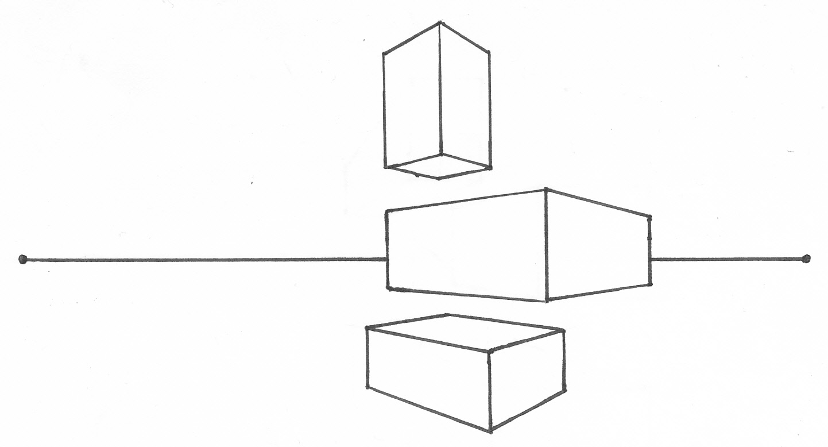
VP1 22
FE
OL
HL
VP2 22

2PT BLOCKS EXERCISE 8th

9
Assignment: Draw your HL between the two dashes below. Place 1 small VP (2 total) at each of the HL. Following the rules of 2 pt perspective create 9 blocks:
- 3 on the horizon line
- 3 above the horizon line
- 3 below The horizon line

Crosshatching
Scribbling

Thatching
Hatching

Pebbling
Stippling

PEN TECHNIQUE SPHERES
Assignment: In the circles below , shade the spheres showing all modeling factors covered in previous notes using the style covered

18

THUMBNAILS

9
Assignment: Draw at least 3 different pictures and choose your best one to enlarge and create your final piece.

PEN & WASH PERSPECTIVE DRAWING
Objective – This project is about showing an understanding of perspective and exploring new media applications: pen and watercolor together.
Project – Create a line drawing that incorporates the obvious use of linear perspective, to create the illusion of space, from an existing photograph. You do not need to plot actual vanishing points and use a ruler unless you want to. Finish the piece by adding a wash using watercolor.
Steps:
- Choose a photograph you are interested in drawing that is a good example of linear perspective
  - Find a picture online or take your own photo. Ideas:

- Single building
- City street
- Room interior
- Birds eye on city

  - Keep in mind that strong lighting will give you more to work with in regard to light and shadow.
- Draw thumbnail to see if you are on the right track
  - Pencil first for guidelines
  - Pen second for finished lines
  - Toy with washes of color.
- Final should be 11x15 inch or larger. You can go as large as you want by using the projector and working from your thumbnail drawing.
- Washes: Finish with washes of watercolor. Consider sticking to a limited color palette. This will help you establish a mood and kep the piece more interesting. Think about where you might put it up to help you decide on colors.
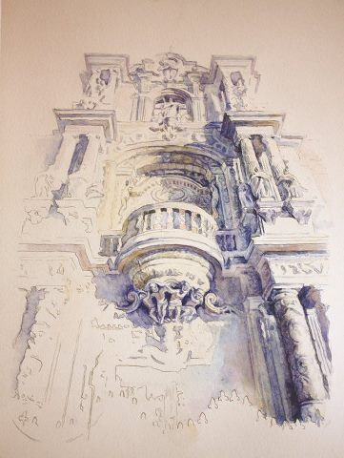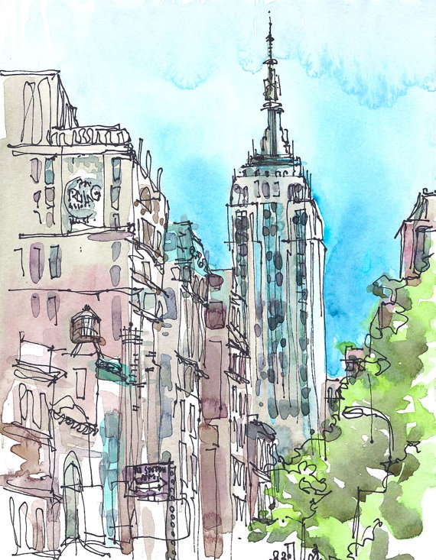

40
Teacher | Student | Description
/10 | /10 | Craftsmanship – carefully crafted & finished
/10 | /10 | Perspective – Photo choice and drawing shows an in-depth understanding of perspective, believable rendering and illusion of space.
/10 | /10 | Color/Value – Interesting use of color
/10 | /10 | Studio Work Ethic – on task when you come in the room, problem solving, positive attitude

CRITIQUE

6
Assignment – Evaluate this project by answering the following
questions. Be descriptive.

- Do you think your project well finished &why? (3pts)

- What was the hardest part for you? Explain . (3pts)

