Portrait Unit
Name:

Objective: Students will learn about the life and work of Amedeo Modigliani and fundamental facial proportions.

7

10
MODIGLIANI NOTES 7th
Assignment: Following allong with the slideshow filling in the notes below.

1. Modigliani was born in the country of ________________. (1/2 pt each)
- He was a ___________ and a ______________.
- He was extremely poor and would sometimes steal stone for sculpting from ____________ ______________.
- Heavy _________________ and _________________ user.
- He died young at the age of 35 from _____________________.
- HE was fascinated by African _________________. And his sculpture and paintings carry some of the same characteristics
List 2 facial characteristics he picked up from some African masks
Feature characteristics (1 pt) | Meaning
7. | 8.
9. | 10.

11. Read the following quote from Modigliani and write a short, 3 to 4 sentence reflective response. Tell me what you think this is about. (2pts)

“When I know your soul I’ll paint your eyes.”

HEAD FEATURE PROPORTIONS 7th

8
Assignment: Draw a head in the space below placing features properly by utilizing guidelines

COLOR SYMBOLISM CHART7th

7
Assignment – Read through the colors below and CIRCLE colors and words that you like or are interesting to you (at least 10, ½ pt each). You will use this chart to capture some aspect of your portraits personality. You will also need to explain in your critique what you were trying to convey about personality in your portrait through color.
Color | description
RED | Excitement, energy, passion, love, desire, speed, strength, power, heat, aggression, danger, fire, blood, war, violence, all things intense and passionate.
PINK | Pink symbolizes love and romance, caring, tenderness, acceptance and calm.
BEIGE/IVORY | Beige and ivory symbolize unification. Ivory symbolizes quiet and pleasantness. Beige symbolizes calm and simplicity.
YELLOW | Joy, happiness, betrayal, optimism, idealism, imagination, hope, sunshine, summer, gold, philosophy, dishonesty, cowardice, jealousy, covetousness, deceit, illness, hazard and friendship.
BLUE | Peace, tranquility, cold, calm, stability, harmony, unity, trust, truth, confidence, conservatism, security, cleanliness, order, loyalty, sky, water, technology, depression, appetite suppressant.
TURQUOISE | Turquoise symbolizes calm. Teal symbolizes sophistication. Aquamarine symbolizes water. Lighter turquoise has a feminine appeal.
VIOLET | Royalty, nobility, spirituality, ceremony, mysterious, transformation, wisdom, enlightenment, cruelty, arrogance, mourning.
LAVENDER | Lavender symbolizes femininity, grace and elegance.
ORANGE | Energy, balance, enthusiasm, warmth, vibrant, expansive, flamboyant, demanding of attention.
GREEN | Nature, environment, healthy, good luck, renewal, youth, spring, generosity, fertility, jealousy, inexperience, envy, misfortune, vigor.
BROWN | Earth, stability, hearth, home, outdoors, reliability, comfort, endurance, simplicity, and comfort.
GREY | Security, reliability, intelligence, staid, modesty, dignity, maturity, solid, conservative, practical, old age, sadness, boring. Silver symbolizes calm.
WHITE | Reverence, purity, birth, simplicity, cleanliness, peace, humility, precision, innocence, youth, winter, snow, good, sterility, marriage (Western cultures), death (Eastern cultures), cold, clinical.
BLACK | Power, sophistication, formality, elegance, wealth, mystery, fear, evil, unhappiness, depth, style, evil, sadness, remorse, anger, anonymity, underground, good technical color, mourning, death (Western cultures).

(2pts) What is your favorite color and does the description characterize you or embody things that are important to you? Is there a color that you identify with or describes you better? Explain your thoughts in a few sentences.

MODIGLIANI PORTRAIT 7th

Project: Create a Modigliani inspired portrait while being deliberate and purposeful about your color choices. The colors your choose should be descriptive of your personality.

Steps:
- On a black sheet of paper, Using pencil divide the paper in quarters from top to bottom and in ½ from side to side.
- In keeping with Modigliani’s altered proportions draw the oval for the head centered at the top and the elongated neck below with shoulders taking up bottom 1/4
- Draw eyes far above center and long thi nose.
- next go over these lines with black oil pastel (not the guideliens we used to divide page)
- Last fill in the colors Be creative with the colors. Maybe she is a smurf and maybe her eyes are hollow like some of Modigliani’s

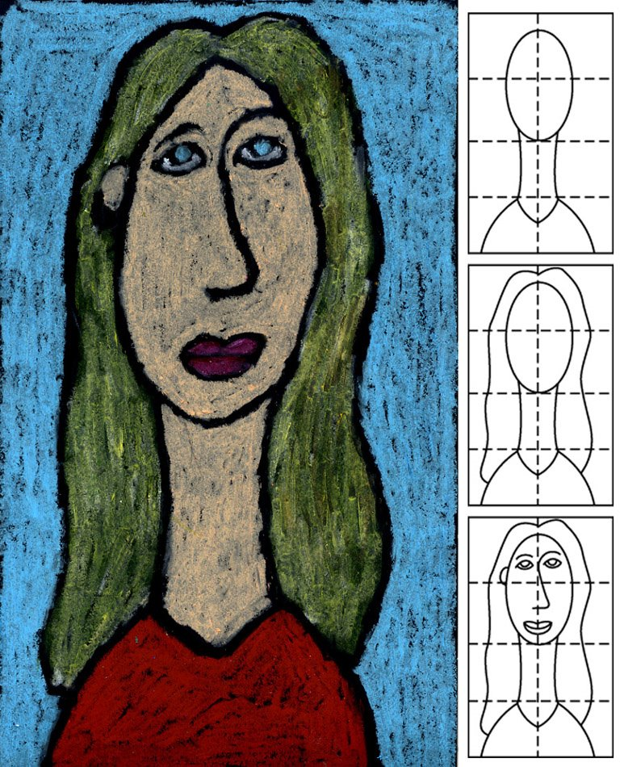

Teacher  40 | Student | Description
/10 | /10 | Fulfills requirements and finished
/10 | /10 | Craftsmanship: careful, clean, neat drawing and coloring covers paper completely.
/10 | /10 | Composition: Clearly captures Modigliani’s proportional preferences: long neck, long nose etc.
/10 | /10 | Studio Work Ethic – on task, problem solving, positive attitude

CRITIQUE 7th

6
Assignment – In complete sentences evaluate the project by answering the following questions and be descriptive.

- Do you think your work is well done and why? (3pts)

- Explain what you think your color choices communicate about your portraits personality. Feel free to look back at the color chart. (3pts)

