Drawing Graphite: Texture & Accuracy Unit
Name:

GRAPHITE NOTES

6.5
Assignment – Choose 5 Pencils from your set and fill the boxes below. This is to help you begin to see how dark and light each pencil is capable of going. Choosing the right pencil for the right value will help you keep from damaging your paper and from excessive texture showing though.

HARDEST (LIGHTEST) DARKEST (SOFTEST)
9H 8H 7H 6H 5H 4H 3H 2H H F HB B 2B 3B 4B 5B 7B 8B 9B

 | PENCIL
PRESSURE |  | 9H OR HARDEST |  | HB |  | 9B OR SOFTEST
 | 1. LIGHT
 | 2. MEDIUM
 | 3. HEAVY

Value Band Notes – I preparation for your value bands use a pencil and fill in the boxes along with Mr. P. (.5pt each)

4. Smooth (.5 pt) | 5. Not Smooth | 6. Transitional | 7. Not Transitional

Bad Bands!

8. Peter Rabbit (.5pt) | 9. Leprosy | 10. Tornado
11. Finger Smudge | 12. Hand Spasm | 13. Premature Lightening

VALUE BANDS

9
Assignment – Make 2 value bands (3 pts each) using your pencil set between lines below. Value bands should change gradually, consistently & smoothly. Avoid bad bands listed above. Use circular pencil strokes. Join the 2 bands into 1 seamless band. (3 pts) Righties should go dark on left and Lefties should go dark on right.

SPHERE DRAWING

10
Assignment – Using the outlines below Shade the sphere using your variety of pencils. Notice there is no distinct outline around the sphere above. Each modeling factor should be obvious in your drawing.

HEAD FEATURE PROPORTIONS

8
Assignment: Draw a head in the space below placing features properly by utilizing guidelines

FEATURE STUDIES

21
Assignment: Draw each of the following features with your teacher and follow along step by step on screen in the space provided below.
- Eye (7pts each)
- Nose
- mouth

FIGURE PROPORTIONS

8
Assignment: Draw a human figure that is 8 heads tall. Know that figure proportions for children vary greatly. See the following page to get an idea.

GESTURE DRAWING

12
LEAST AMOUNT OF LINE, MOST AMOUNT OF INFORMATION
Assignment: Watch the following YouTube video to familiarize yourself with gesture drawing and see other samples. Assignment is to draw 6 or more large gesture drawings on the next 2 pages. Watch more of Matt’s videos to see a real master at work. Keep figure proportions in mind and make an effort not to make the head too big.
YouTube Video: http://www.youtube.com/watch?v=qrGnMar2pAI&list=FLrY4MscLNWBHMFH8CCmdp5w&index=105

GESTURE DRAWING (CONT.)
Assignment: 6 or more total in the last 2 pages

STUDIES

10
Assignment: This is a great exercise when trying to improve your drawing of any object. This page should be filled with 5 or more studies of the object you will be doing. Each should be numbered in order from your first to your last. Focus on improving each one by finding things you can improve on from the last one. Also trying different approaches

THOUGHTS ON DaVINCI’S CONTRIBUTION TO THE SCIENCES
Exerpts found at: http://legacy.mos.org/LEONARDO/scientist.html

One cannot exaggerate the unpleasantness of Leonardo's anatomy studies. Cadavers are already pretty awful, even when refrigerated and pickled in formaldehyde, but Renaissance Italy had no such niceties. Leonardo, in his fervor for knowledge, held countless creepy vigils with the local corpses, and their annoying tendency to decay forced him to work as quickly as possible. He described it as "living through the night hours in the company of quartered and flayed corpses fearful to behold," but as usual his curiosity pushed him ever onward.

Alas, even Leonardo fell for some bogus theories. He was fascinated by the study of physiognomy, the "science" of evaluating a person's character by his or her facial features. Although utter codswallop, physiognomy was all the rage until the beginning of this century, when scientists finally chucked it once and for all.

Leonardo the scientist bridged the gap between the shockingly unscientific medieval methods and our own trusty modern approach. His experiments in anatomy and the study of fluids, for example, absolutely blew away the accomplishments of his predecessors. Beginning with his first stay in Milan and accelerating around 1505, Leonardo became more and more wrapped up in his scientific investigations. The sheer range of topics that came under his inquiry is staggering: anatomy, zoology, botany, geology, optics, aerodynamics and hydrodynamics among others.

In a study of cervical vertebra shown from different perspectives, Leonardo notes: "[Both] former and contemporary authors have produced written reports [about anatomy] in tormentingly long-winded and confused styles. However, through a concise portrayal from different perspectives, things are described definitively; and to avoid that my gift to mankind could be lost [to time], I teach the technique of reproducing things by printing." These remarks heralded the birth of a new method of scientific study: the systematic, descriptive method of the natural sciences, which was the predominant method of scientific study well into the 19th century.

As his curiosity took him in ever wilder directions, Leonardo always used this method of scientific inquiry: close observation, repeated testing of the observation, precise illustration of the subject object or phenomenon with brief explanatory notes. The result was volumes of remarkable notes on an amazing variety of topics, from the nature of the sun, moon and stars to the formation of fossils and, perhaps most notably, the mysteries of flight

DaVINCI NOTES

5
Assignment: Following allong with you’re the slides and fill in the notes below. (.5pt each)

- DaVinci was the (original) _____________ man.
- Previous Anatomists relied on ______________ descriptions.
- DaVinci systematically dissected over ______ abandon corpses.
- Without _______________ and modern embalming he was racing decay as he created his studies.
- He often made ____________ to draw from because the dissection process was to messy to get a good look at the shape of the parts he was studying.
- DaVinci was the first to systematically draw the inner workings of the human body. However since the modern _____________ _____________ was not in existence his work had little influence.
- He even built a ____________ model of a heat that he could pump fluids through to study the circulatory system. It wasn’t until the 1980’s that an MRI scan was able to see a beating hard and confirm that Leonardo had been almost completely _____________ way back in the late 1400’s.
- Early practitioner of what resembled the _______________ method before it was a standard in western science.

ANATOMICAL STUDY
Objective – This project is about showing proficiency with graphite and an in-depth understanding of some anatomical feature.
Project – Focus on accuracy in object shape and size then on a wide range of values when shading. Eliminating the outlines is essential when trying to make a realistic drawing, and happens during and after the shading process.
Steps:
- Choose a picture you are interested in drawing in pencil
  - Find a picture online or take your own photo. Ideas:

- Bones in hand
- Eye
- Foot
- Figure
- Skeleton
- Back Muscles

  - Keep in mind that a wide range of values (bright whites and dark shadows) will make the picture more dynamic and much easier to make look 3D
NOTE: Avoid using a flash at all cost. It will result in front light and few significant shadows serving to flatten your picture and not give you a wide range of values. FORM lighting is essential so choose your photograph wisely
- Convert to black & white if necessary
- Tape pic in SB (on left if you are a right handed and right if you are a leftie.)
- Tape down appropriately sized grid transparency over picture
- Draw final on facing page.
- Drawing should fill a SB page
- Position drawing on page with some white margin around the side.
- Drawing Steps
  - Contour Lines (LIGHT!!!)
  - Shade
  - Eliminate lines if you wish it to look more realistic
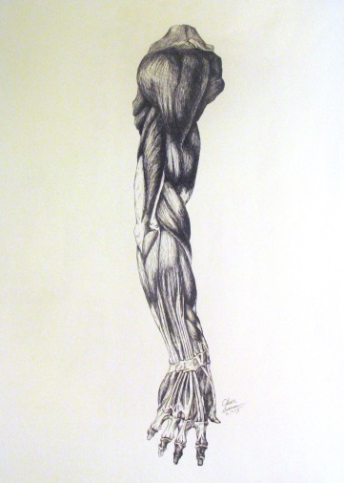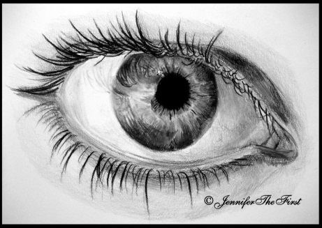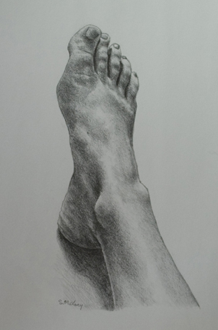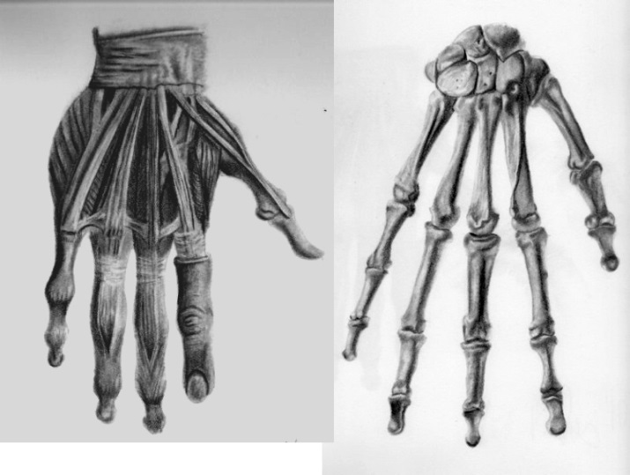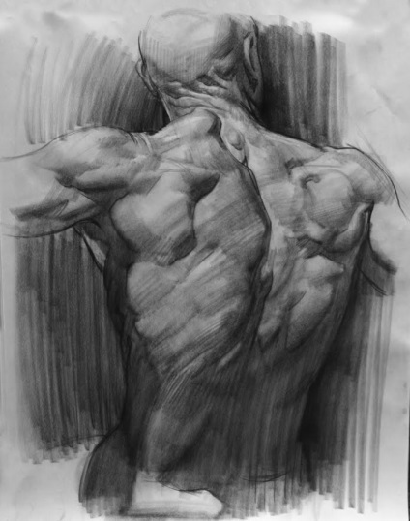

40
Teacher | Student | Description
/10 | /10 | Fulfills requirements and finished: Drawing shows an in-depth understanding of some anatomical part. Image choice
/10 | /10 | Contour lines – accurately, carefully placed
/10 | /10 | Shading – wide range of values, positioned accurately, consistent quality of shading  Eliminate Lines – remaining lines should not decrease quality of drawing.
/10 | /10 | Studio Work Ethic – on task when you come in the room, problem solving, positive attitude
CRITIQUE

6
Assignment – Evaluate this project by answering the following
questions. Be descriptive.

- Are you happy with your work? Why? (3pts)

- What is the hardest part for you? Explain (3pts)

