Figure Sculpture Unit
Name:

7
ALBERTO GIACOMETTI
Assignment: Following allong with the slideshow filling in the notes below. (.5pt each)

- Giacometti was born in ___________ and died in ______________.
- He was a ______________ sculptor and the child of a famous _____-__________ Painter.
- He studied under Antoine Bourdelle an associate of Auguste Rodin who sculpted The ________________.
- He was a sculptor associated with the _______________ movement and was later excommunicated from their association. (remember Dali’s melting clocks?)
- Died of ___________ Disease.
- Early work was extremely ______________ and his later work became more and more abstracted.
- Scholar William Barrett in Irrational Man: A Study in Existential Philosophy (1962), wrote the following.

The attenuated forms of Giacometti's figures reflect the view of 20th Century modernism and existentialism that modern life is increasingly empty and devoid of meaning.

Write a few sentences explaining why you think this critic might get this idea from Giacometti’s sculptures?(3pts)

FIGURE PROPORTIONS

10
Assignment: Draw a human figure that is 8 heads tall. Know that figure proportions for children vary greatly. Infants as a standard are as little as 4 heads tall.

Draw the proportions of your figure and see how many heads tall it is. (2pts)

FOIL FIGURE PROJECT
Objective – Learn about the sculpture of Alberto Giacometti, handle foil as a sculptural medium showing an understanding of figure proportions and movement

Design Requirements
- Capture a believable sense of movement with your figure(s)
- You may (but are not required to) include props
- Mounted and free standing on matt board
- You may combine characters in the same piece.

Building stage
- Following the steps below build your figure
  - Using a square piece of foil fold it into thirds (like a letter) in 1 direction and
  - Fold it in half in the other directions
  - Make 3 cuts as directed by your teacher
  - Gently bring in the center or the piece of foil while preserving the length of each part (torso, legs arms, head)
  - Gently start crushing arms legs and head phile preserving their length
  - Bring out subtleties neck, chin, articulated hands, torso twist joints, muscles for a more interesting form.

Mounting stage (2 classes)
- Hot glue figure to mat board as cleanly as possible. Glue should not be obvious.

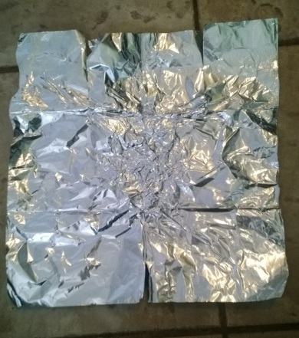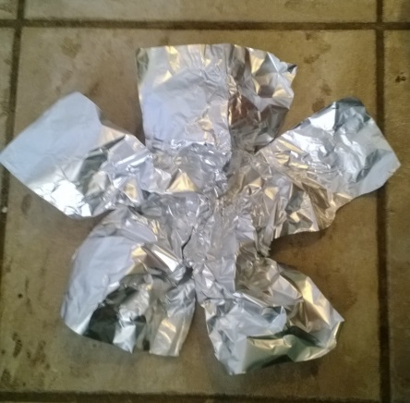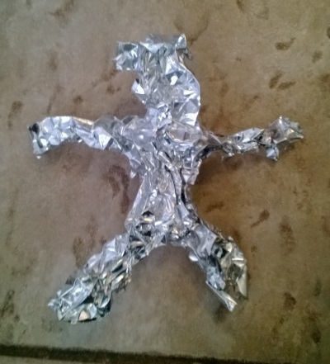

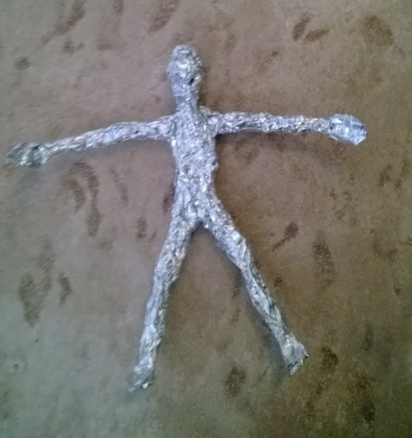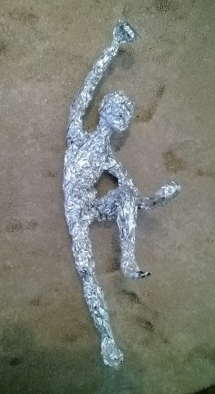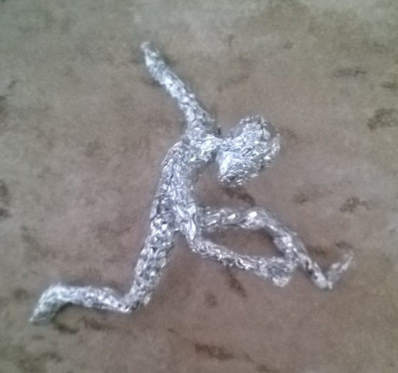

40
Teacher | Student | Description
/10 | /10 | Fulfills requirements and finished
/10 | /10 | Craftsmanship: well crafted, brought out features that show an understanding of basic anatomy.
/10 | /10 | Composition: Successfully captured figure in an active and dynamic pose.
/10 | /10 | Studio Work Ethic – on task, problem solving, positive attitude

CRITIQUE

6
Assignment– In complete sentences evaluate the project by answering the following questions and be descriptive.

- What was the hardest part of the sculpture and how did you handle the frustration? (3pts)

- Are you satisfied with the quality of your work and why? (3pts)

