Art 8 Impossible Form Unit
Name:

DEVIL’S PITCHFORK/BIVLET 8th
Assignment: Read this together as a class to familiarize yourself with impossible figuers and the Penrose triangle.

Impossible Figure:
A type of optical illusion consisting of a two-dimensional figure which is instantly and subconsciously interpreted by the visual system as representing a projection of a three-dimensional object although it is not actually possible for such an object to exist (at least not in the form interpreted by the visual system). Watch Video

Devils Pitchfork or Bivlet:
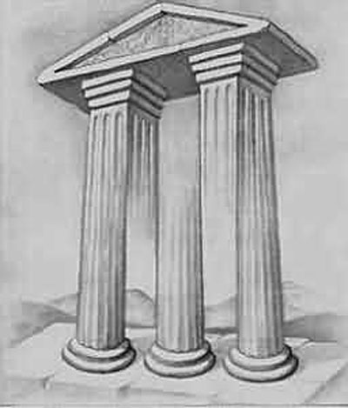

The impossible fork (Seckel 2002, p. 151), also known as the devil's pitchfork (Singmaster), blivet, or poiuyt, is a classic impossible figure originally due to Schuster (1964). While each prong of the fork (or, in the original work, "clevis") appears normal, attempting to determine their manner of attachment shows that something is seriously out of whack. The second figure below shows three impossible figures: the ambihelical hexnut in the lower left-hand corner, tribox in the middle, and impossible fork in the upper right.

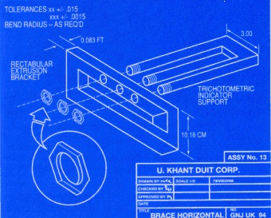
About the time of the impossible fork's discovery by Schuster (1964), it was used by Mad Magazine as a recurring theme. Their term for it was "poiuyt," which corresponds to the third row of a standard keyboard typed from right to left. The "poiuyt" was commonly used in Mad throughout the 1960s indicating absurdity or impossibility. http://mathworld.wolfram.com/ImpossibleFork.html

PRACTICE ON DOT PAPER

8
Assignment – Following along with Mr P’s demo below. Draw 3 line, 4 line & 5 line objects. In the remaining space try to create your own based on some of the principles that make the first 3 work. (2pts)

WATER COLOR METHODS

4
Assignment – Following along with mr P’s demo on the Paper provided. Make sure to put your name on the paper and get it turned in on the cart.
Value bar
Wet on Dry
Wet into wet
Blowing

PEN & INK VALUE BLOCKS 8th

7

10
Assignment: Using a fine tip marker create 3 different values of each different method.

Stippling
Pebbling
Thatching
Hatching
Crosshatching
Scribbling
CYO
Light
Medium
Dark
SOUPED-UP DEVIL’S PITCHFORK 8th
Objective: Learn pen and ink methods (watercolor methods) and show an understanding of impossible forms by creating your own.

Project: Follow along with teacher and create this step by step. We are going to use Pen & Ink to create a souped-up devil’s pitchfork. The steps are easy but include measuring and focused attention. Listen closely and follow directions below.
Steps:
- First measure across the bottom and top of your 10” paper and make a mark every inch. Using a ruler draw a straight line between your dots. You should have 9 parallel lines
- Number lines 1 – 9 left to right
- BOTTOM: Draw a downward sloping angle from line 1 (2” from bottom of page) to line 8 (1”)
- BOTTOM: Draw a upward sloping angle from line 8 (1”) to 9 (1.5”)
- BOTTOM: Above the lines you just drew draw another line parallel to step 3’s line between line 1 (3”) & line 8 (2”).
- BOTTOM: Draw another line beginning Line 1 (3.5”) and ending at Line 8 (2.5”)
- BOTTOM: Draw an upward leaning line, parallel with the line in step 4, between lines 2 & 3, 5 & 6
- TOP: Draw line between Line 2 (1”) & Line 9 (2”)
- TOP: Draw line between Line 1 (1.5”) & Line 8 (2.5”)
- Go over all your finished lines with a ruler and sharpie
- Erase all pencil working lines
1-2 4-5 6-8 8-9
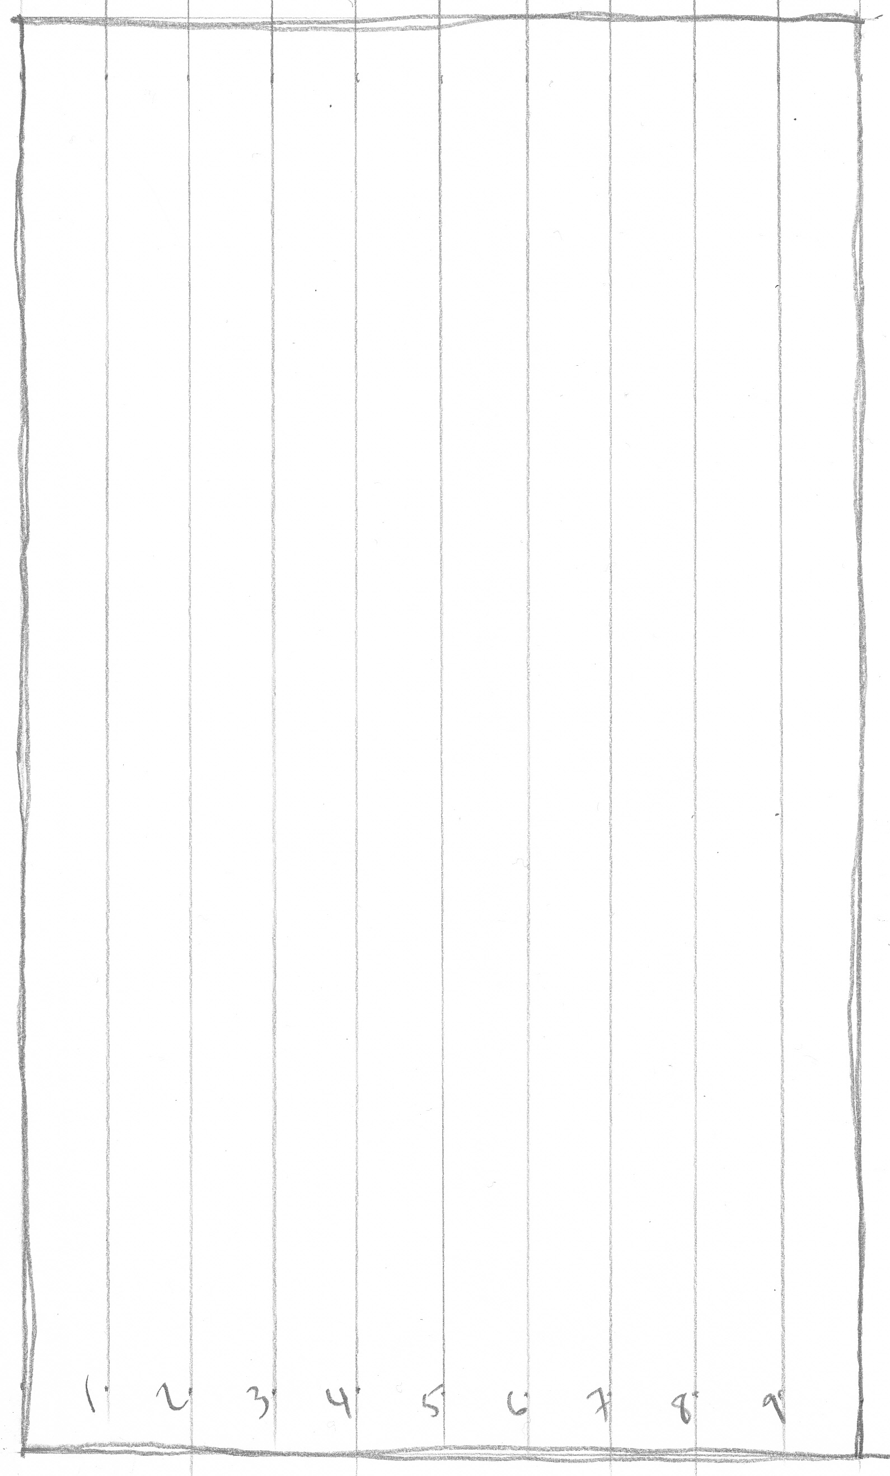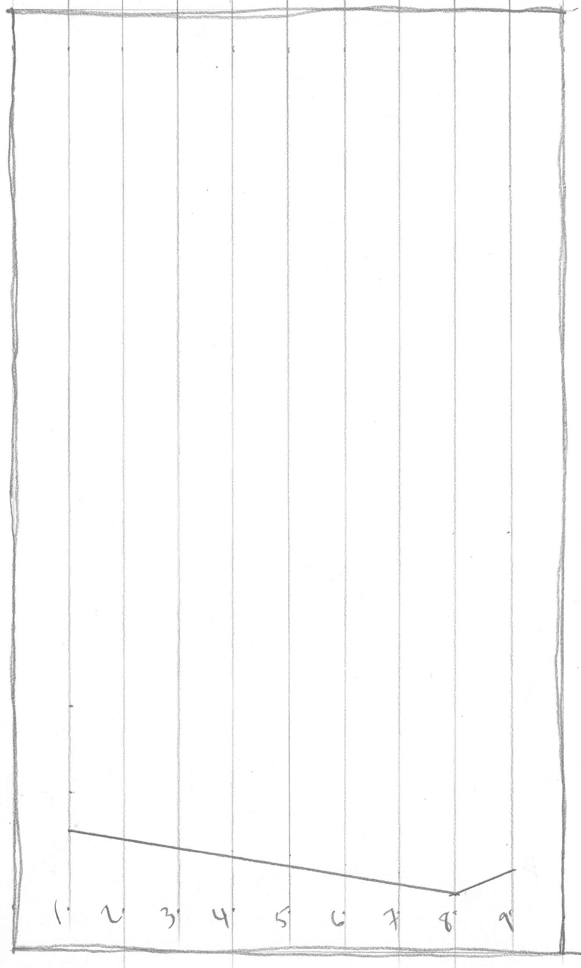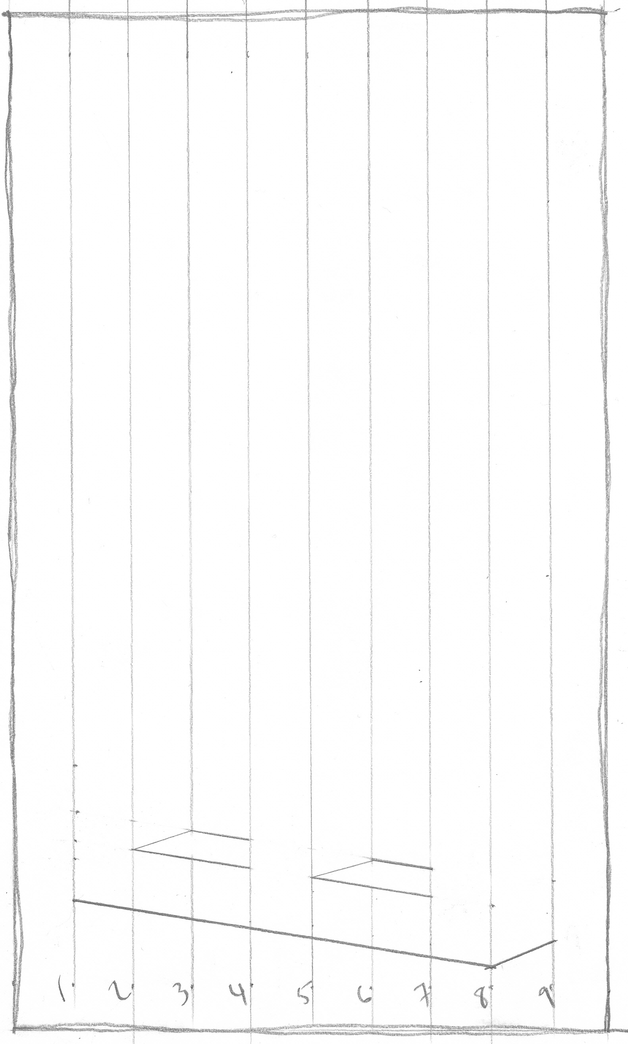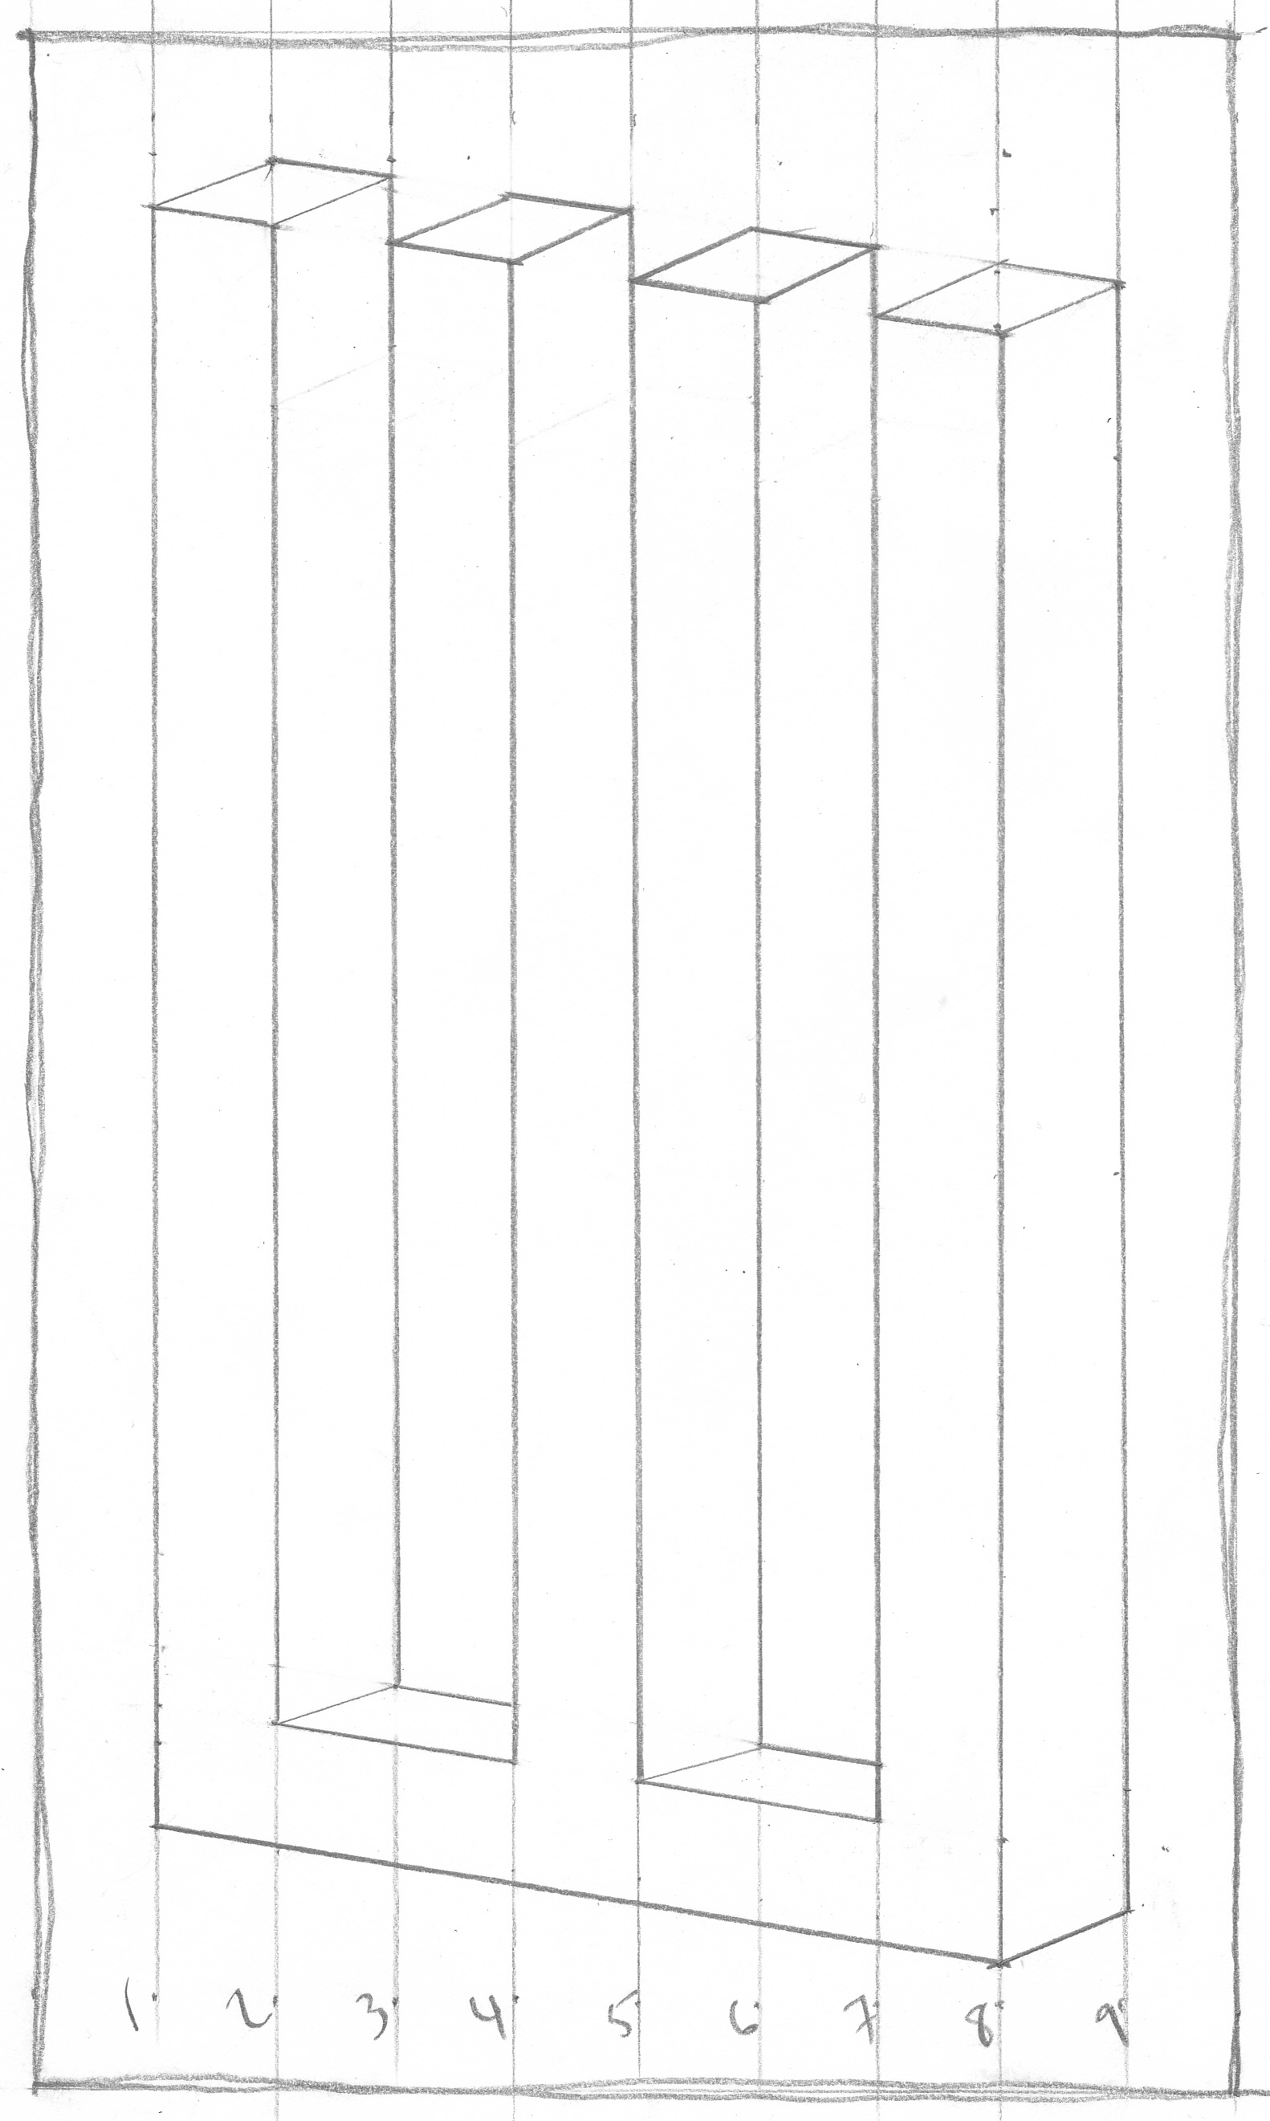

40
Teacher | Student | Description
/10 | /10 | Fulfills requirements and finished
/10 | /10 | Line: Consistent line quality, neatly drawn with clear attention to craftsmanship
/10 | /10 | Color: Carefully painted using 3 different values. Surfaces must transition smoothly from end to end.
/10 | /10 | Studio Work Ethic – on task, problem solving, positive attitude
CRITIQUE 8th

6
Assignment – In complete sentences evaluate the project by answering the following questions and be descriptive.

- Do you think your work is well finished and why? (3 pts)

- Do you find this style of artwork more or less interesting than traditional painting and drawing? Explain. (3pts)

