Portrait & Color Unit
Name:

Objective: Students will learn about the life and work of Paul Klee and fundamental color theory terminology and Color Schemes

14

10
KLEE NOTES 6th
Assignment: Following allong with the slideshow filling in the notes below.

1. Klee was born in the country of ________________. (1/2 pt each)
- Taught in Germany at an art and design school known as the ___________.
- He fled from Germany after being targeted by the ____________.
- Klee was fascinated by ______________ drawings.
- He created over ______________ works of art.
- He was not only a Painter. He was also extremely skilled in ___________ and ___________.
- Klee is famous for his writings on ___________ _________ and for the rich ___________ in his work.
Characteristics of different periods of his artwork
6. Early (1 pt) | 7. Late

10. Read the following quote from Paul Klee and write a short, 3 to 4 sentence reflective response. Tell me what you think about the quote and explain.(2 pt)
“To emphasize only the beautiful [in art] seems to me to be like a mathematical system that only concerns itself with positive numbers.”

9.5
COLOR NOTES 6th
Assignment: Following allong with your teacher fill in the notes below

Vocabulary:

1. Primary (3) –
2. Secondary (3) –
3. Intermediate (6) –
4. Warm colors (3) –
5. Cool colors (3) –
6. Tint –
7. Shade –
Color Wheel – Using color pencils fill in color wheel with th3e colors in order all the way around. You may need to combine some colors to get your intermediates.

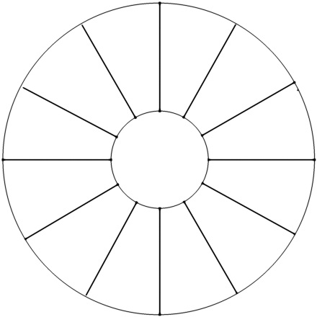
COLOR SYMBOLISM CHART6th

5
Assignment – Read through the colors below and CIRCLE the words that describe your personality. Find at least 10 and make your color choices from there. Choose 3-5 different colors that capture your personality More than that can be too much and lack character.
Color | description
RED | Excitement, energy, passion, love, desire, speed, strength, power, heat, aggression, danger, fire, blood, war, violence, all things intense and passionate.
PINK | Pink symbolizes love and romance, caring, tenderness, acceptance and calm.
BEIGE/IVORY | Beige and ivory symbolize unification. Ivory symbolizes quiet and pleasantness. Beige symbolizes calm and simplicity.
YELLOW | Joy, happiness, betrayal, optimism, idealism, imagination, hope, sunshine, summer, gold, philosophy, dishonesty, cowardice, jealousy, covetousness, deceit, illness, hazard and friendship.
BLUE | Peace, tranquility, cold, calm, stability, harmony, unity, trust, truth, confidence, conservatism, security, cleanliness, order, loyalty, sky, water, technology, depression, appetite suppressant.
TURQUOISE | Turquoise symbolizes calm. Teal symbolizes sophistication. Aquamarine symbolizes water. Lighter turquoise has a feminine appeal.
VIOLET | Royalty, nobility, spirituality, ceremony, mysterious, transformation, wisdom, enlightenment, cruelty, arrogance, mourning.
LAVENDER | Lavender symbolizes femininity, grace and elegance.
ORANGE | Energy, balance, enthusiasm, warmth, vibrant, expansive, flamboyant, demanding of attention.
GREEN | Nature, environment, healthy, good luck, renewal, youth, spring, generosity, fertility, jealousy, inexperience, envy, misfortune, vigor.
BROWN | Earth, stability, hearth, home, outdoors, reliability, comfort, endurance, simplicity, and comfort.
GREY | Security, reliability, intelligence, staid, modesty, dignity, maturity, solid, conservative, practical, old age, sadness, boring. Silver symbolizes calm.
WHITE | Reverence, purity, birth, simplicity, cleanliness, peace, humility, precision, innocence, youth, winter, snow, good, sterility, marriage (Western cultures), death (Eastern cultures), cold, clinical.
BLACK | Power, sophistication, formality, elegance, wealth, mystery, fear, evil, unhappiness, depth, style, evil, sadness, remorse, anger, anonymity, underground, good technical color, mourning, death (Western cultures).
KLEE COLOR SELF PORTRAIT 6th

Project: Create a Paul Klee inspired portrait while being deliberate and purposeful about your color choices. The colors your choose should be descriptive of your personality.

Steps:
- Using pencil trace the cardboard circle template about 1 ½ inches from the top and side
- Draw neck and shoulders
- Draw eyes (different sizes) & mouth off center
- Draw 5 lines through face to cut it up into patches
- Draw 3 lines through body
- Black oil pastel lines
- Fill in spaces with color (3 to 5 main colors to keep it focused)

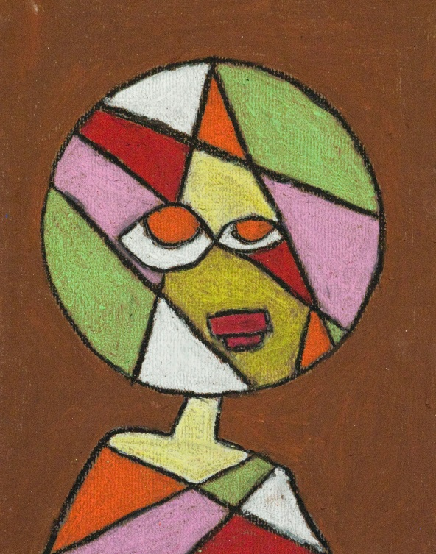

Teacher  40 | Student | Description
/10 | /10 | Fulfills requirements and finished
/10 | /10 | Craftsmanship: careful, clean, neat drawing.
/10 | /10 | Composition:  - Deliberate color choices (3-5) that are descriptive of your personality.
/10 | /10 | Studio Work Ethic – on task, problem solving, positive attitude

CRITIQUE 6th

6
Assignment – In complete sentences evaluate the project by answering the following questions and be descriptive.

- Do you think your work is well done and why? (3pts)

- Explain how the colors you chose represent you. Feel free to look back at the color chart. (3pts)

