Drawing Charcoal: Value Unit
Name:

VALUE NOTES

6.5

Assignment – Answer the following questions s along with Mr. P. (.5pt each)

1. Value:

Colors also have value circle the word that describes the value associated with the following colors

2. Violet: Light Dark (circle one)

3. Yellow: Light Dark (circle one)

Shade the spheres below showing the different kinds of lighting:

4. FRONT 5. FORM 6. SIDE 7. RIM 8. BACK

MODELING FACTORS: Following along with your teacher fill in the boxes with the appropriate factor.

12.
11.
10.
9.
13.

CHARCOAL FAMILIARITY EX
CHARCOAL Assignment – 1) Fill in a patch of black using the various kinds of charcoal listed below. 2) Then erase part of the spot to get an idea how easy each one erases.

14. VINE | 15. COMPRESSED | 16. POWDERED | 17. PENCIL | 18. CONTE

VALUE BANDS

8
Assignment – Make 2 value bands (4 pts each) using charcoal between the lines below. Value bands should change gradually, consistently & smoothly. Righties should go dark on left and Lefties should go dark on right.

SPHERE DRAWING

10
Assignment – Using the outlines below shade the sphere using charcoal method demoed by teacher. There should be no distinct outline around the sphere when you are finished. Each modeling factor should be obvious in your drawing.

CHOOSE YOUR MASK
Assignment: On the following 2 pages you will find 4 masks. 2 are from a ¾ view and may prove more challenging and more interesting to some of you. The other 2 are straight on offering symmetry which will moderate the difficulty level. Choose one of the following for your project.

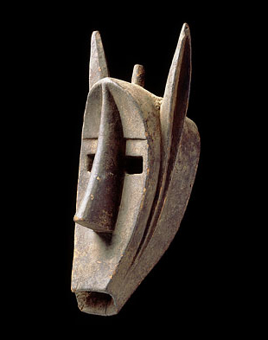
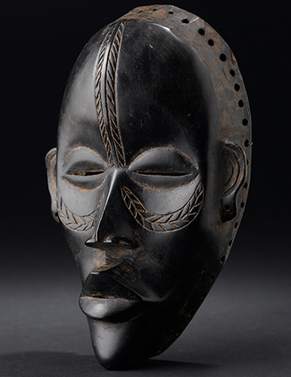
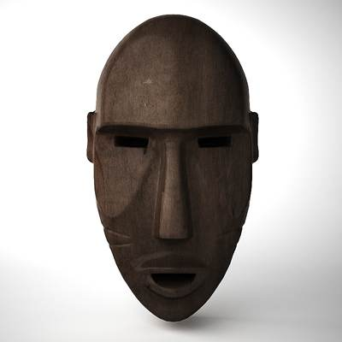
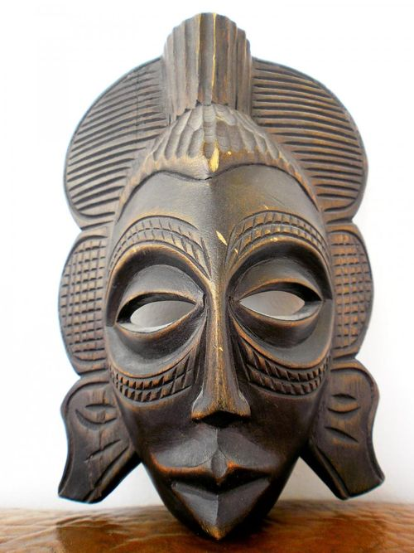

VALUE STUDY EX

10
Assignment – Cut out the mask you would like to draw and attach it in the box below that will not be under your arm while drawing. (Right handers attach to left box, lefties the opposite) Draw a simple value sketch as you observe your instructor.

CHARCOAL AFRICAN MASK

Project – Focusing on light and shadow as well as a wide range of values draw the mask as it appears. Keep in mind that you will not be graded on accuracy of contours so painstaking attention to this will not necessarily improve your grade. If it looks weird because things don’t line up and there are obvious problems it will hurt but some variation, as long as it works, is acceptable.

Steps:

- 13 x 24 inch piece of white paper
- Crush some vine charcoal on a paper towel with your finger and rub it all over the page.
- OPTION A: Draw your contours with an ERASER
- Keep the paper towel handy and use it to reapply, it’s kind of like erasing
- OPTION B : Use the compressed charcoal to fill in the negative space behind the mask
- Continue on applying compressed charcoal and using your eraser to reveal every subtlety in the values
- Be willing to erase and move features whenever necessary.
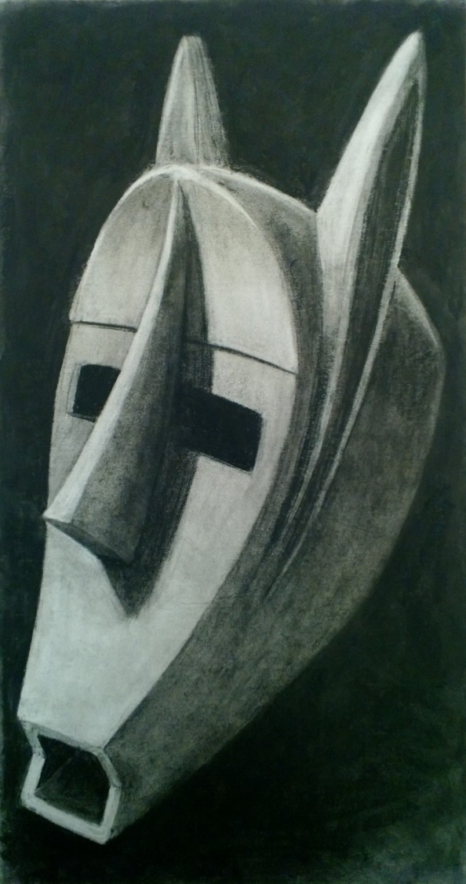

40
Teacher | Student | Description
/10 | /10 | Contour lines – accurately, carefully placed
/10 | /10 | Shading – wide range of values, smooth & consistent
/10 | /10 | Eliminate Lines – edges are no longer defined with contour lines.
/10 | /10 | Studio Work Ethic – on task when you come in the room, problem solving, positive attitude

CRITIQUE

6
Assignment – Evaluate this project by answering the following questions.

- Are you happy with your work? Why? (3pts)

- What is the hardest part for you? Explain (3pts)

