MS Draw Cartooning Unit
Name:

GETTING STARTED MS

10
Assignment: Follow allong with Mr. P and create 5 cartoon heads. Remember to use pencil first and then finish with marker and even some color (Turn Paper sideways.) KEEP A SCRAP PIECE OF PAPER UNDER EACH PAGE SO THE MARKER DOESN’T BLEED THROUGH.

FEATURE COLLECTION MS

14
Assignment: Use the following space to collect 8-10 samples of features you can find online

Head

Eyes

Nose

Mouth

Ears

Eyebrows

Hair

SPIKE & MIKE MS

8
Assignment: Some people say dogs look like their owners, or maybe owners look like their dogs! Draw a dog and his owner using similar features that look alike.

FRONT AND ¾ VIEW MS

8
Assignment: Draw a character with mr P from the front and then the same character from ¾ view

DOUGS MUG MS

8
Assignment: Using the following face create 4 distinctly different characters by changing the hair

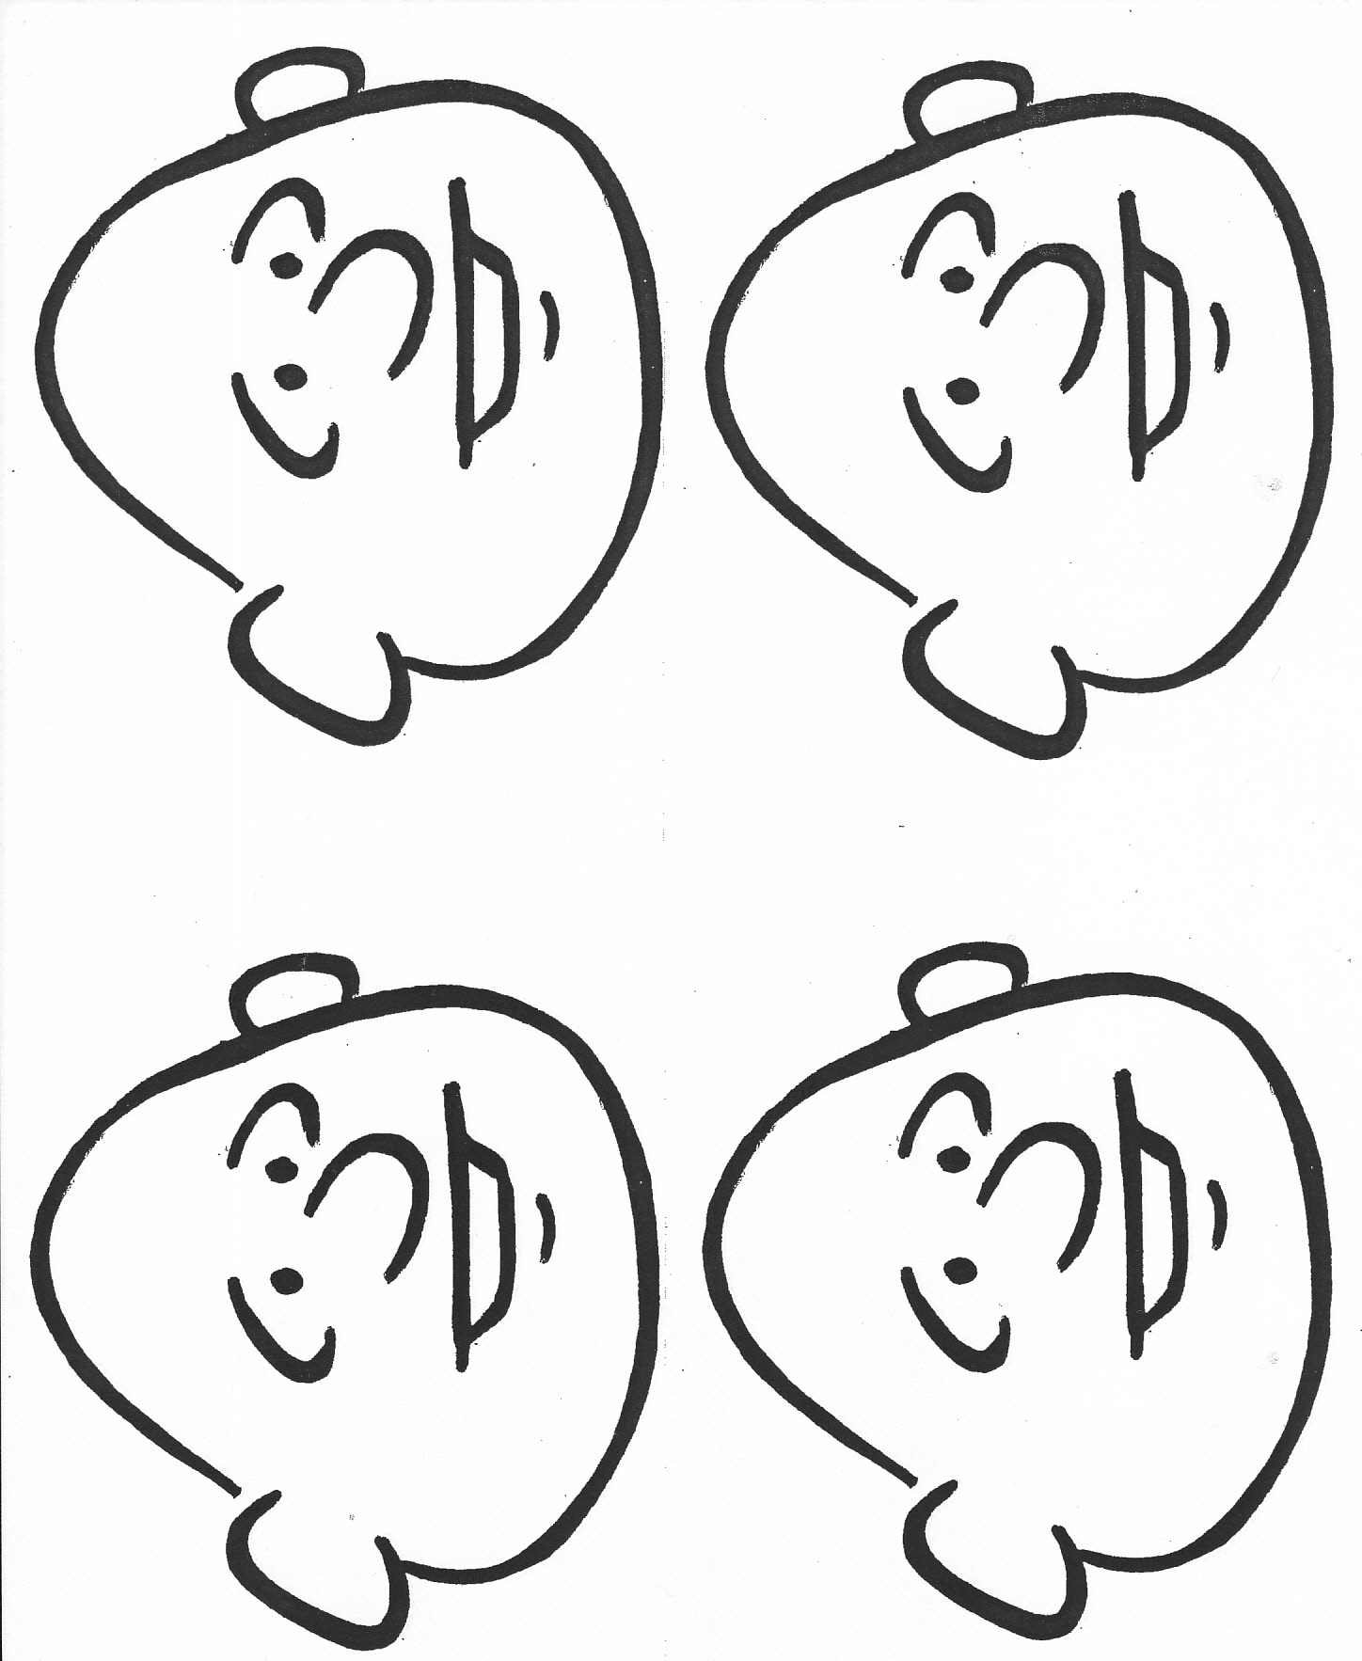

BRAINSTORMING PORTRAITS MS

10
Assignment: FIRST READ PROJECT DESCRIPTION ON NEXT PAGE. In the space below create cartoon drawings of yourself and people that you know and care about. You will use these drawings to help you decide on the upcomoming portrait project. Create at least 5 different people.

3 CARTOON PORTRAITS MS

Project – Draw 3 cartoon portraits. 1 should be of yourself and the other 2 should be of people in your life that you care about or respect.
- Begin by drawing on an 8 ½ x 11 piece of copy paper in pencil
- Draw the finished lines with marker
- Finish by loosely adding in color with chalk pastel
- Cut a cartoon frame that fits the image as seen below
  - First trace an 8 ½ x 11 sheet of paper to make sure your frame will cover the edges of your drawing.
  - Draw decorations and cut it out.

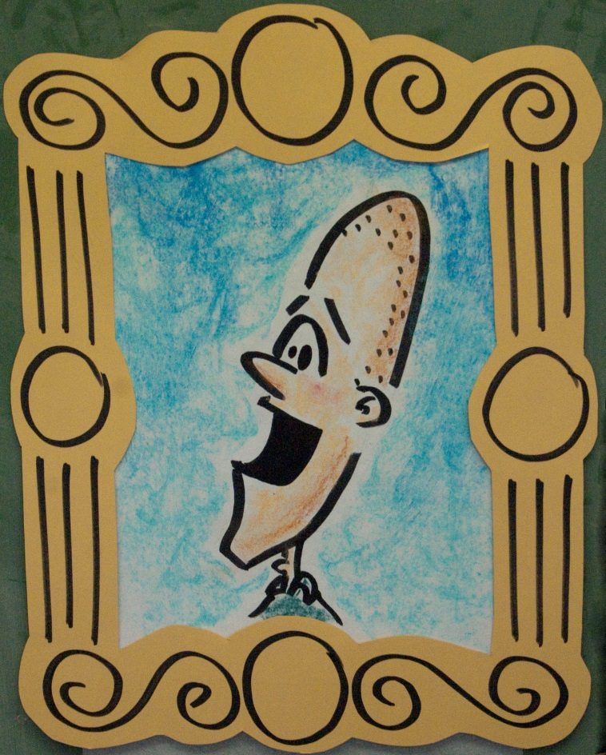

40
Teacher | Student | Description
/10 | /10 | Fulfills requirements and finished including the cartoon frame
/10 | /10 | Craftsmanship: Clear carefully drawn lines and neatly colored color spaces.
/10 | /10 | Composition: Fill 8 ½ x 11 copy page
/10 | /10 | Studio Work Ethic – on task, problem solving, positive attitude

6
CRITIQUE
Assignment– In complete sentences evaluate the project by answering the following questions and be descriptive.

- What are 2 things you did well? (2pts)

- What are 2 things that might improve your project? (2pts)

- Why did you choose the 2 people you chose? (2pts)

