Draw Cartooning Unit
Name:

DIFFERENT EXPRESSIONS SAME CHARACTER MS

8

Assignment: Following allong with your teacher create 4 different expressions on the same character’s face by changing primarily the mouth, eyes, eyebrows and extras.

CREATE 5 OF YOUR OWN MS

10
Assignment: In the space provided create 5 of your own characters using your collection of features. You can draw them from the front or ¾ view.

8 DIFFERENT EXPRESSIONS MS

16
Assignment: In the space provided create 8 or more different expressions of your own. Circle your 5 favorite and these will be the ones you use on your project

5 EXPRESSIONS MS

Project: Draw 5 different cartoon expressions on the same character’s face by changing primarily the mouth, eyes, eyebrows and extras.

Steps:
- Using Pencil draw your character in a 3x3 in box
- Trace each base character onto 3x3 inch copy paper either by putting it up on the window or light table or just looking closely.
- Create each expression in pencil
- Ink each expression
- Use color deliberately to help add expression to your character

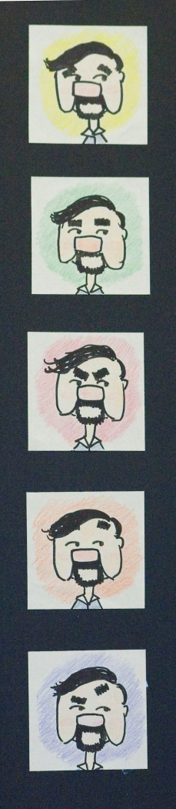

40
Teacher | Student | Description
/10 | /10 | Fulfills requirements and finished including the cartoon frame
/10 | /10 | Craftsmanship: Clear carefully drawn lines and neatly colored color spaces.
/10 | /10 | Composition: Each drawing is the same size, and centered consistently
/10 | /10 | Studio Work Ethic – on task, problem solving, positive attitude

4
CRITIQUE
Assignment– In complete sentences evaluate the project by answering the following questions and be descriptive.

- Which expression do you like the best and why? (2pts)

- List one thing that could improve your project? Explain? (2pts)

