Abstract Sculpture Unit
Name:

HENRY MOORE NOTES

9
Assignment: Following allong with the slideshow filling in the notes below. (.5pt each)

1. Moore was born in ___________ and died in ______________.
- Arguably the most important _______________ sculptor of the ______ Century.
- He fought in WWI and was injured in a ____________ attack.
- Worked abstractly before abstraction and ___________ were in vogue.
- Influenced by _____________, Pre-Columbian and _______________ sculpture.
- Contemporaries/instructors said he was feeding on _____________. Implying that these influences were inferior since realism was the ultimate goal.
- Believed in “___________ to ___________” meaning the original material (stone, wood) should show through in order to remain loyal to the sculptural medium.
- First major mature work was titled Reclining ______________ in Wood (1936)
- Other than the human body his work was also inspired by ______________, ___________, ____________ & ____________. You can see this influence as he applies them to the human form.
- Read the following quote and write a quick response. What does this make you think of? Or what do you think he is saying about art?(2pts)

If an artist tries consciously to do something to others, it is to stretch their eyes, their thoughts, to something they would not see or feel if the artist had not done it. To do this, he has to stretch his own first. (Henry Moore)

6
ABSTRACT ART
Assignment: Read the following essay about Abstract art and write a response to the question.

By Lynne Taetzsch
When I paint, I am not attempting to capture the likeness of a landscape or figure. My subject is the painting itself. In spite of this, some viewers immediately try to pin down a realistic image in my art. Not that seeing things in abstract art is a crime, even if the artist didn't put them there. But you miss an opportunity to see more if you spend all your energy trying to turn the painting into something you can name, like a figure or flower or landscape.
What do you actually see when you look at the painting? Color, shape, line and texture are the physical elements that combine to make up the image. A selection of dark, heavy shapes may impress you as somber; light, airy images as mystical; balanced, temperate forms as peaceful. Shape, color and form have meaning in and of themselves. We react emotionally to these elements even if they create no recognizable object for us to hang onto. Thus, a painting of ragged, angular forms in deep reds will evoke an entirely different feeling from one in soft curves of yellow and white.
The handling of space--or the illusion of space--is another element in the artist's toolbox. Are you drawn into a world of three-dimensional space stretching beyond the framework of the painting, as you might be in a landscape? Or are you kept visually taut, as a skater on a pond, skimming across a two-dimensional surface? The impression of depth, perspective, airiness, solidity, and other spatial relations are created and controlled by the artist.
The overall composition or design of a painting is what guides the viewer's eye. Have you ever looked at a painting or photograph and felt it was off balance? One of the big differences between amateur snapshots and professional photographs is the quality of the composition. In an amateur photo, perhaps all the action is centered on the left, with nothing but empty space on the right. The lopsidedness gives you a sense of unease. (Of course an artist may use this unease deliberately as well.)
Composition is one of the fundamental tools an art student is taught. The goal is to have a balance of visual elements without making the weight so balanced that the art becomes boring. If everything on the left is exactly equal to the right, and the top to the bottom, you may have balance, but you lose interest.
Getting the composition right, or balancing the elements of color, line and shape while maintaining a dynamic tension-is a major preoccupation of the painter. If you add a blue brushstroke to the bottom left-hand corner, for example, you may have to change something in the top right-hand corner because of it. You can't concentrate on one section at a time, ignoring the rest of the canvas, and expect to end up with a composition that works.
Energy is the life force that is present in all good art. This is not something that is easily defined, but it is the opposite state of static flatness. It is this energy that makes a painting speak to you, and makes an artist's work original and identifiable as the work of that artist. Energy is created out of the artist's materials and tools, but the end is more than the means in the same sense that a musical composition is so much more than a collection of notes.
The next time you look at an abstract painting, or any kind of "modern art," don't begin by searching for some identifiable object from your world. Instead, try to enter the world the artist created. Relax and let your eye leisurely wander over the painting's surface. Let your heart and mind react to its colors, shapes, and textures. Let yourself be drawn into the illusion of its spaces, the action of its lines, the mood of its atmosphere.
Step back and look at the painting from a distance. What is its impact as you approach it?
Move up close and explore the intricacies of brushstrokes, paint thicknesses and compositional details. See how the parts are woven together to form the whole.
Give the painting time. No artwork can be understood and appreciated in a ten second glance. Good art should grow on you, becoming more interesting and more enjoyable to look at as you live with it.
You may still see things in abstract paintings, finding birds and trees and animals hidden in the forms. This is as natural as turning clouds into recognizable shapes. But by opening your eyes to the possibilities of the world the artist created, you may see more than you ever expected to see in abstract art.

- Propose how you think abstract art can be evaluated. How do we decide if it is good or not?

PRINCIPLES STUDY

9

Assignment: In The space provided below (choose 3 principles) describe how you use the principles at work in sculptures a-d. Write a principle in the blank next to the # and then describe how you see that principle at work in one of the sculptures below.(3pts each) Remember that principles are carried out throught the strategic use of the elements so you should be able to describe it in terms or how a particular element is used.

a. 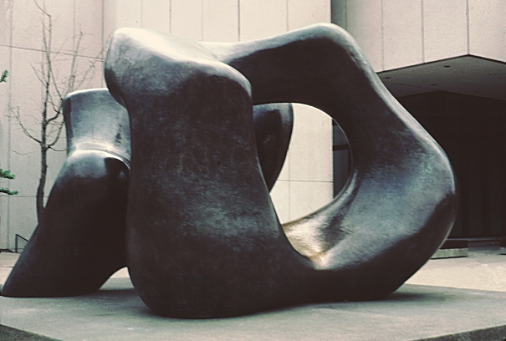 | b. 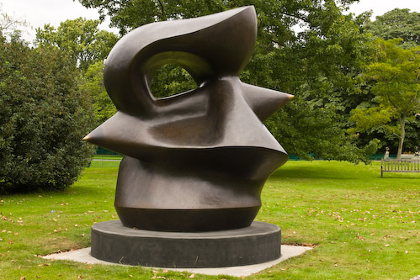
c. 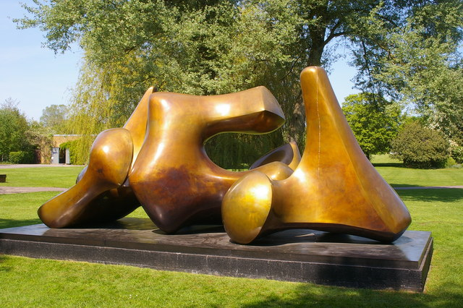 | d. 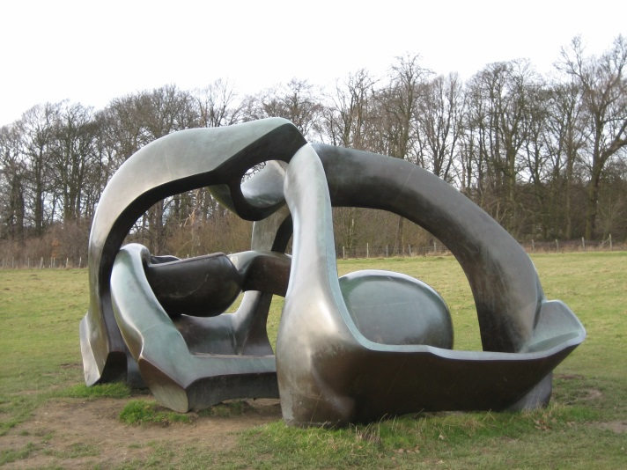

- ____________________:

- ____________________:

- ____________________:

ABSTRACT PROJECT
Objective – Learn about the sculpture of Henry Moore and handle sculpting/floral foam as a sculpture medium in a subtractive way.

Design Requirements
- Must not have a front and back. Should be sculpted in the round
- Must be completely abstract and not purposefully be an abstracted form
- Must be an open form meaning you can see through the sculpture somewhere
- Must go through the spray-painting process to finish it so it looks like stone

Building stage (4 classes)
- Mark off 1 inch thick base by drawing an line around the bottom
- Use sure form tools and knife to rough out shape taking off corners and opening form
- Use rifflers to further hone shape

Finishing stage (2 classes)
- Smooth with your finger to create a finished surface.
- Spray-paint to create a stone like finish

Note: Remember there is no turning back when something breaks off so precision, craftsmanship and careful handling are essential. However, be ready for things to break off and be willing to work creatively with these unexpected setbacks.

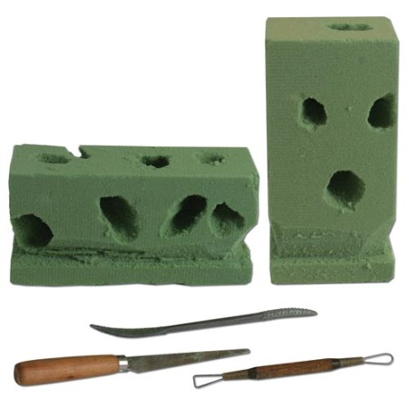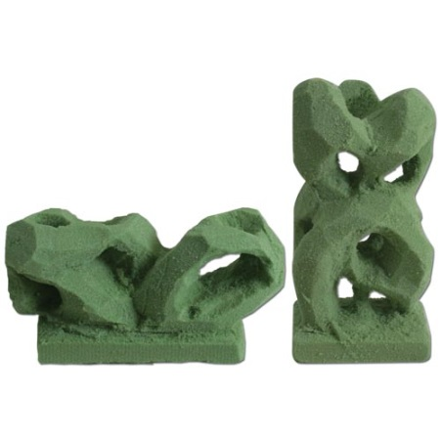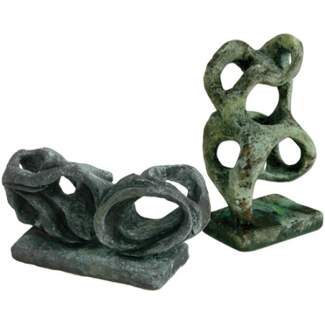

40
Teacher | Student | Description
/10 | /10 | Fulfills requirements and finished
/10 | /10 | Craftsmanship: Smooth to the point that tool marks are invisible and painted covers entire form (no foam showing)
/10 | /10 | Composition: open, loose flat sides and corners. Origiobnal block shape should not dictate the final shape of project. Proj captures extreme abstracted style of Henry Moore.
/10 | /10 | Studio Work Ethic – on task, problem solving, positive attitude

CRITIQUE

6
Assignment– In complete sentences evaluate the project by answering the following questions and be descriptive.

- Are you happy with your work? Explain. (3pts)

- What do you think of Abstract sculpture? (3pts)

